**Pharmacology**

RESEARCH CONCERNING THE RADIOPROTECTIVE AND IMMUNOSTIMULATING EFFECTS OF DEUTERIUM-

DEPLETED WATER

**W. BiLD¹, I. STEFANESCU³, I. HAULICA², C. LUPUSORU¹. G. TITESCU³. R. ILIESCU², V. NASTASA²**

*¹ University of Medicine and Pharmacy lasi*. *Department of Physiology and Department of Pharmacology*

*² Laboratory of Experimental and Applied Physiology of the Romanian Academy*

*³ Institute Institute of Criogeny and Isotopic Research Ramnicu-Valcea*

**Abstract. Mice fed for 15 days with Deuterium-Depleted Water (30 ppm deuterium) had a statistically significant increased survival rate compared with control groups fed with normal distilled water (150 ppm deuterium), after 8.5 Gy irradiation (61 % survival in the test group versus 25% in the control group). The hematological picture showed that normal WBC. RBC and platelet counts were maintained in the test groups. Immunological parameters (serum opsonic and bactericidal capacity, bactericidal capacity of the peritoneal macrophages) showed a marked increase in the test groups compared to a severe decrease in the control groups. Auxiliary tests using chemical radiomimetics (hydrochloric embihine) and immunosuppressors (cyclophosphamide) showed a strong protective effect of deuterium-depleted water against the decrease of the leukocyte counts and other immunologic parameters. In conditions of experimental inflammation induced with subcutaneous-implanted pellets, deuterium-depleted water feeding resulted in a statistically significant increase of the inflammatory response, demonstrated by increased percentages of PMN and lymphocytes in the peripheral blood and the increased phagocytic capacity of the peripheral blood PMN. Experimental infections induced with K. pneumoniae 506 and S. pneumoniae 558 in mice irradiated or treated with cyclophosphamide showed increased, non-specific immunity parameters. All results show a marked intensification of the immune defenses and increased proliferation of the peripheral blood cells, probably accounting for the radioprotective effects.**

**Key words: deuterium-depleted water. Immune response, chemical radiomimetics, immunosuppressors, inflammatory response**

In the almost 70 years that **have passed sines** the discovery of deuterium in natural water (Urey ***et al.*** 1932), many studies were conducted for establishing its biological actions in animals and plants. It has been observed that while the small, normal amounts (around 145-150 ppm) are not toxic, increased amounts of deuterium,, in excess of 15-20%. determine structural, metabolic and functional alterations in various degrees (Kashner et. al. 1997).

Having a lower diffusion coefficient than normal water, deuterated water enters the cells with more difficultly, induces the reduction of the substrate diffusibility

through membranes and reduces the speed of the cellular enzymatic reactic (Каtz. I960). That is the source of its many inhibitory effects, including. vasodilator ones (Wang *et al.,* 1993).

Unlike the biological changes determined by the excess of deuterium water, the effects of reducing its concentration below the normal values have be less studied.

The only data published are those of Somlyai e***t al.*** (1993). concerning it inhibition of both the growth rate of fibroblast cultures and of tumor development in a tumor transplanted in mice.

Recently, we have found an increase of the basal tone and of the vascula reactivity in the rat (Haulica *et al.,* 1998).

Starting from these findings, we have looked into the radioprotective effect of deuterium depletion, in order to identify the biological consequences ol lowering the concentration of that isotope in the body water.

As an instrument for reducing deuterium concentration in the organism of the laboratory animals, we used deuterium-depleted water (DDW) (27-30 parts per million deuterium compared with 145-150 parts per million deuterium).

Deuterium-depleted water was provided by the Institute of Criogeny and Isotopic Research Ramnicu-Valcea.

**I. DIRECT RADIOPROTECTIVE EFFECTS OF DEUTERIUM-DEPLETED**

**WATER**

Considering the radiomimetic effects of heavy (deuterated) water, a partial deuterium depletion was induced in tab animals (mice), using the long term administration of deuterium-depleted water as drinking water. The animals were then submitted to an LD50, irradition dose of 850R.

**MATERIALS AND METHOD**

12 groups of 10 age-matched male. Swiss mice have been used. Their body weight was around 15-20 g.

**6** of the **groups** (the study group) received exclusively dry food and DDW ad libitum for **15** days, while **6** groups (the control group) received the same food and bi-distilled water ad libitum.

The DDW had a 27-30 ppm deuterium concentration while the distilled water had a 145-150 ppm concentration.

After 15 days, following ***4-6*** hours of adaptation in the irradiation container. **6** groups were irradiated as described below:

- The animals were irradiated ***in toto,*** 20 at a time (a control group and a test group, differently marked with colors for differentiation), in a closed cylindrical container made out of 0.5 mm - thick glass, with a surface of about 300 cm, at a distance of 3 cm from the base. The irradiation duration was of 20-40 minutes, according to the output of the irradiation device. Contention was performed using perforated cardboard lid, for relative immobilization. The device used was a cobaltotherapy unit with an output of 30, 35 r/min. belonging to the Oncology -Radiotherapy Clinic of the University Clinic "Sf. Spiridon" in Iasi. The totally received dose was LD50 850 R at 7-70 days.

After irradiation, the animals were brought back to their initial boxes. Their survival was followed during 7 days or until survival rate 50% of the initial groups was reached. Survival time in hours and any macroscopic changes have been monitored. Then, the survivors were sacrificed and an RBC, WBC and platelet count was performed, together with an estimation of the. leukocyte formula. The spleens were removed for immunological testing (T splenic lymphocytes with clustering capacity), while the flat bones, liver and lymph nodes were used for hystopathological observation. Peritoneal washout fluid was collected (with Hanks solution) in order to identify peritoneal macrophages.

**RESULTS**

**DIRECT RADIOPROTECTIVE EFFECTS**

The groups fed with DDW for 15 days showed a statistically significant increase of die survival rate after LD50 irradiation with gamma radiation.

|  |  |  |  |
| --- | --- | --- | --- |
|  | **Survival** | **Death** | **Total** |
| **Control** | **10** | **30** | **40** |
| **Test** | **15** | **15** | **40** |
|  | **35** | **45** | **80** |

Survival rate in controls: ***25%.***

Survival rate in tested animals: 61%.

According to the T test, the differences of the average values in the two groups are greater than random. This *results* in a statistically significant difference (P = 0**.00062)** (Fig. 1).

The cause of death was known to be acute irradiation illness. We therefore studied immune deficiency due to leukopenia, hemorrhagic gastrointestinal troubles and the hematologic picture of both groups.

Thus, an insignificant thrombocytopenia was observed in the test groups compared to the control group.

Erythrocytes, which are least affected by irradiation, were relatively depleted in the control groups, remaining within normal limits for the DDW-fed groups (Fig. 2).

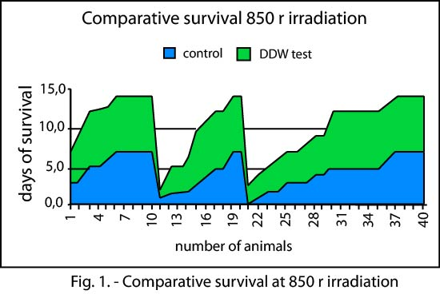

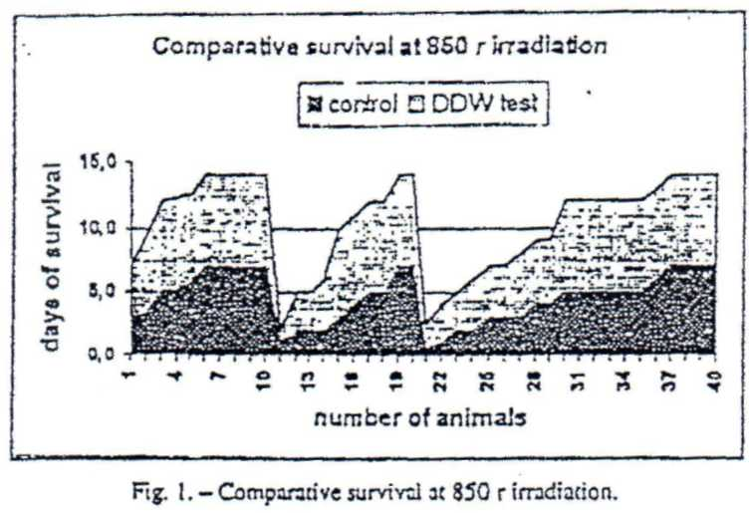

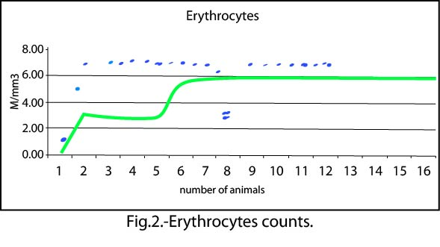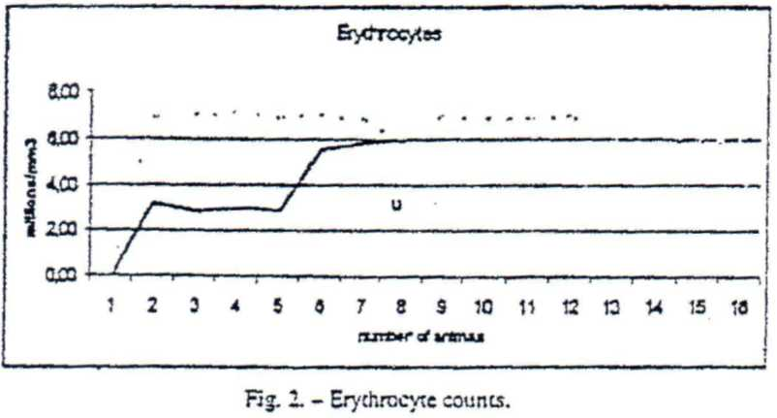

The WBC remained within normal limits, with a slight lymphocytosis and an insignificant reduction of the monocytes count, compared with a severe leukopenia in the control groups.

Leukocytes, the main marker of irradiation disease, were severely depleted in the control groups and remained within normal limits for the DDW-fed **groups,** which demonstrates a real **radioprotective action** of the treatment (Fig. 3).

Auxiliary immunologic tests were performed in order to determine the defense capacity level of irradiated organisms against infectious aggression.

Opsonic and bactericidal characteristics of the serum from irradiated animals were tested, together with the phagocytic capacity of the peritoneal macrophages.

These tests showed a statistically significant increase in the parameters for the DDW-fed animals when compared with those of the animals that were fed distilled-water. The tests assessed the number of surviving bacterial colonies in a standard culture of S. aureus that had been subjected to the serum from die tested animals or to the action of the peritoneal washout fluid (Fig. 4).

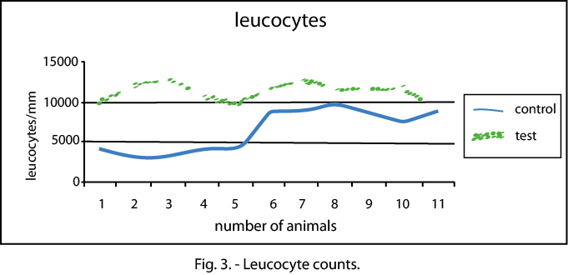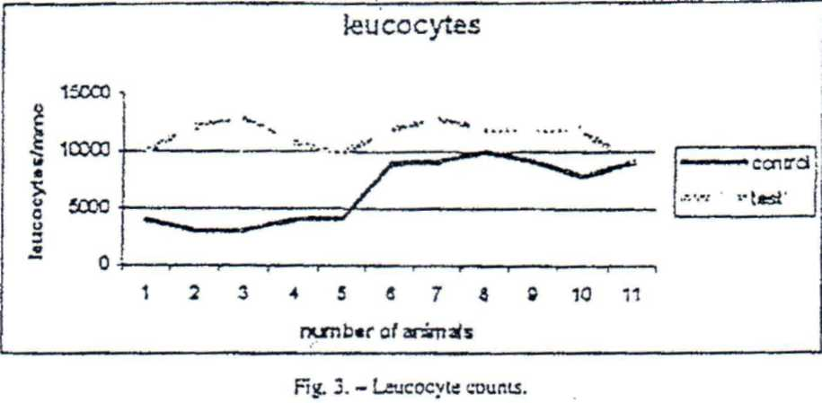

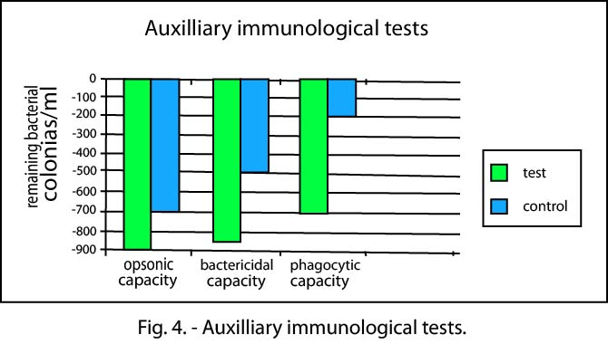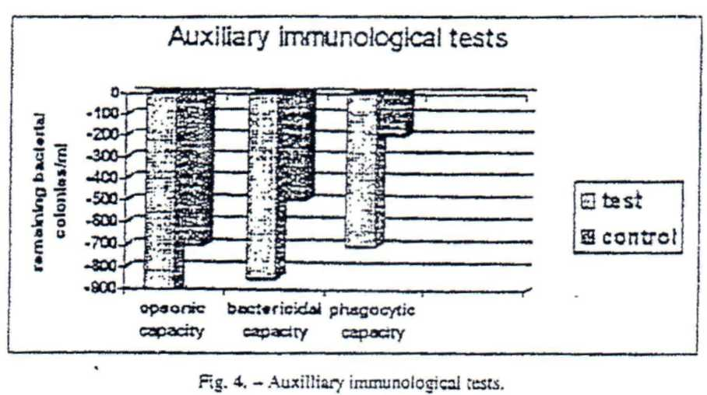

Another marker of me immune defense which was studied were the splenic T lymphocytes with clustering capacity. Here are the results:

M1=9%DDW 16%16%

M2=10%17%15%

M3=10%18%15%

In order to widen the study area, an adjacent experiment was performed by administrating karyolysine (hydrochloric embihine), a chemical radiomimetic agent derived from nitrogen-mustard and used for leukocyte depletion in leukemias and lymphomas. Maintenance and feeding of the animals as well as DDW administration were similar to those described above. Administration consisted in LD50 - 4.4 mg/kg in two groups of Swiss male mice, 15-20 g body weight, 110 µg in 0.25 ml saline, i.p.

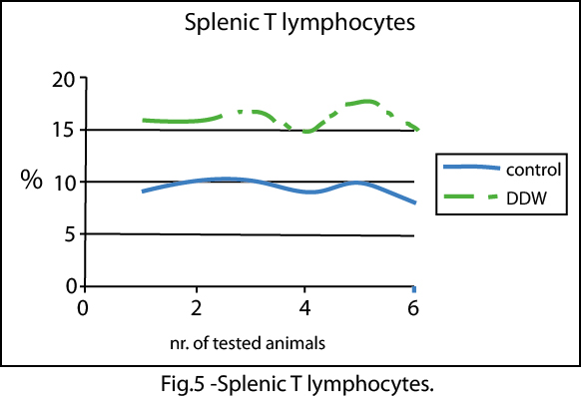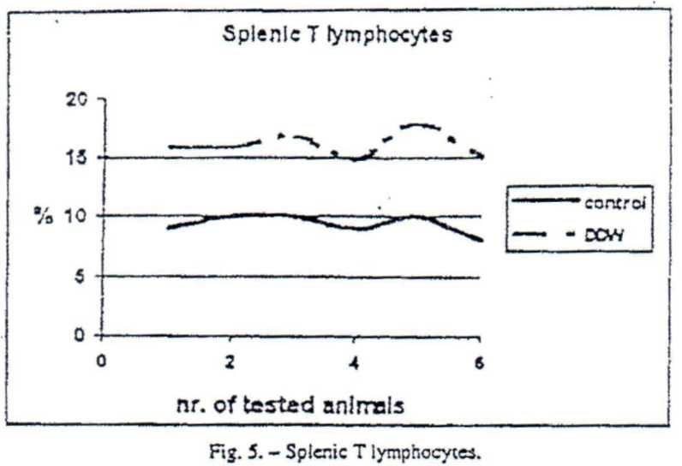

The survival rate in the test group was significantly increased (only 1 animal from the test group died before day 7), while the control group death rate was 50%.

The hematological picture showed that erythrocytes and leukocytes stayed within normal limits, compared to a marked decrease of those same elements in the control groups. A certain degree of thrombocytopenia (without statistical significance) was noted, while the leukocyte formula remained within normal limits, with a slight lymphocytosis and an insignificant reduction in the monocytes.

**CONCLUSIONS**

A clear radioprotective action due to deuterium depletion was observed in the animals in the test group when using exclusive hydration with 30 ppm DDW.

As we **are** aware of the mechanism that determines the acute irradiation disease and the effects of the irradiation and of the administration of chemical radiomimetic substance on fast-dividing cellular lines, we **can assume that there is** a protective **effect on the irradiated** organisms.

For **a** more detailed study of the immunostimulatory effects, complementary immunological investigations were performed.

**II. EFFECTS OF DDW ADMINISTRATION IN RATS WITH EXPERIMENTAL CHRONIC INFLAMMATION**

The purpose of the experiment was to study certain immune parameters in lab animals with experimental chronic inflammation.

**MATERIALS AND METHOD**

Four groups of 6 Wistar rats each were used. They weighed 120-150 g, had a uniform gender distribution and were treated for 14 days through cso-gastric catheter as follows:

1. group one (1) normal saline 0.089% NaCl. 0.5 ml/100 g body weight/rat/day;

2. group (1p) - subcutaneous implanted flank pellets, normal saline. 0.5 ml/100 mg body weight/rat/day;

3. group 2 - DDW. 0.5 ml/100 g body weight/day;

4. group 2p - subcutaneous pellets; DDW 0.5 ml/100 g body weight/rat/day.

The solutions were administered in only one daily dose.

Before treatment (Mo) and also after 14 days of treatment (M1), the following determinations were made:

- RBC count, WBC count leukocyte formula;

- phagocytic capacity of the peripheral blood PMN (Nitro-Blue-Tetrazolium test);

- activity of the serum complement.

Upon beginning the treatment, we performed a subcutaneous implantation of sterile cotton pellets, weighing 62 mg, bilaterally on the flanks. After 7 days, the pellets were aseptically removed and the treatment was continued, according to the above-mentioned protocol.

The determined parameters are part of a set of tests for evaluating the immunological effects of therapeutic agents in experimental research using lab animals, adapted by C't'lina Elena Lupujoru. in 1995. after R. Hong (1987).

***RESULTS***

In the animals with a normal immune system, treated with normal saline, no changes of the RBC count in the peripheral blood were observed. In animals with experimental chronic inflammation, treated with normal saline, a statistically significant decrease can be observed for the RBCs in the peripheral blood at M1 compared with Mo.

In the animals treated with deuterium-depleted water and with subcutaneously implanted pellets, the experimentally induced inflammatory process did not produce a statistically significant decrease of the RBC count at M1, compared with Mo.

WBC count in the peripheral blood:

In control animals, treated with normal saline, no statistically significant changes at ***M1*** compared with M0 were observed.

In animals with subcutaneously implanted pellets and treated with normal saline, the inflammatory process induced a statistically significant increase of the WBC count in the peripheral blood at M1 compared with M0 and compared with the control group, without experimental chronic inflammation.

Deuterium-depleted water produced a statistically significant increase of the WBC count in the peripheral blood, both in rats with a normal immune system and in those with experimental chronic inflammation. In animals with subcutaneous pellets, deuterium-depleted water induced a statistically significant stronger stimulation of this parameter than in rats with a normal immune system.

The results obtained after determination of the percentage of PMN. lymphocytes, eosinophils, basophils and monocytes in peripheral blood are listed below:

• normal saline does not change these parameters;

• experimentally-induced chronic inflammation induces statistically significant increases in the PMN and lymphocyte percentages in the animals from the control group, created with saline;

• statistically significant decreases in the basophilic and monocyte percentages in the animals from the control group, treated with saline.

Deuterium-depleted water produces statistically significant increases of the PMN and lymphocyte percentages and statistically significant decreases of the eosinophilic, basophilic and monocyte percentages from the peripheral blood in M1 compared with Mo and compared with the matching control groups.

The increase in the PMN percentages and the decreases in eosinophil, basophilic and monocyte percentage are to a greater extent statistically significant for the groups with subcutaneuosly implanted pellets and treated with deuterium-depleted water compared with the groups with normal immune system and treated with deuterium-depleted water.

The lymphocyte percentages grow to similar values in animals treated with depleted-deuterium pellets and with normal immune system, respectively with experimental chronic inflammation.

**RESULTS OBTAINED WITH THE NITRO-BLUE-TETRAZOLIUM (NBT) TEST**

Normal saline does not influences this parameter (group I).

Experimentally induced chronic inflammation produces an increase in the phagocytic capacity of the PMN from the peripheral blood, with a statistical significance in M1, compared to M0 and compared with the NBT test in group I.

Deuterium-depleted water produces a statistically significant stimulation of this parameter both in animals with normal immune system and in those with subcutaneous pellets (groups 2 and 2p).

The stimulation of the phagocytic capacity of the PMN from the peripheral blood is to a greater extent statistically significant in group 2p compared to group 2.

**RESULTS OBTAINED FROM THE DETERMINATION OF THE ACTIVITY OF THE SERUM COMPLEMENT**

It can be observed that in animals with a normal immune system, deuterium-depleted water does not influence the activity of the serum complement, while in rats with chronic inflammation, deuterium-depleted water produces a statistically significant activation of the serum complement at M1 compared to Mo and compared with the control groups (1 and 1p) and with group 2.

**CONCLUSIONS**

In rats with a normal immune system, deuterium-depleted water stimulates the non-specific immune defense. This is proven by:

- the increase of the PMN and lymphocytes from the peripheral blood;

- the increase in the phagocytic capacity of the PMN from the peripheral blood (NBT test).

In rats with experimentally induced chronic inflammation, the stimulation of the non-specific immune defense is much stronger. One can observe statistically significant higher increases of the PMN percentages and also of the NBT test.

Also in rats with experimentally induced chronic inflammation, the deuterium-depleted water induces a statistically significant activation of the serum complement (probably, through the alternate pathway).

The decrease in the eosinophil and basophilic percentages, higher in the animals with experimental chronic inflammation, leads to the hypothesis of a possible anti-allergic effect of deuterium-depleted water.

Also, deuterium-depleted water antagonizes the effect of decrease in the number of RBC in the peripheral blood, produced by experimental chronic inflammation.

After 14 days of administration (0.5 ml/100 body weight), deuterium-depleted water **did** not influence the parameters of the specific **immunity.**

**III. THE EFFECTS OF ADMINISTRATION OF DEUTERIUM-DEPLETED WATER IN MICE WITH EXPERIMENTAL INFECTION WITH KLEBSIELLA PNEUMONIAE 507 AND STREPTOCOCCUS PNEUMONIAE 558. IRRADIATED WITH LD50 GAMMA RADIATION AND TREATED WITH IMMUNOSUPRESSOR AGENTS (CYCLOPHOSPHAMIDE)**

We used groups of б Swiss male mice each, weighing 15-20 grams. Six groups (the study group) received exclusively dry food and ad libitum deuterium-

depleted water for 15 days, and 6 groups (the control group) the same food and ad libitum distilled water.

The animals were infected by intraperitoneal injection of 0.1 ml bacterial cultures of *Klebsiella pneumoniae* 507 and *Streptococcus pneumoniae* 558. We also nude up groups pre-treated with cyclophosphamide (40 Mg/g in one, single intraperitoneal dose or pre-treated with irradiation. 850 r in one application).

Survival during seven days has been followed, then the survivors have been sacrificed and hematological and immunological tests were performed.

Mortality has been significantly higher in al! groups of mice treated with distilled water, irrespective of the pre-treatment. The survival rate has been clearly improved in mice with experimental infections and with cyclophosphamide immunosuppression treated with deuterium-depleted water (Fig. **6).**

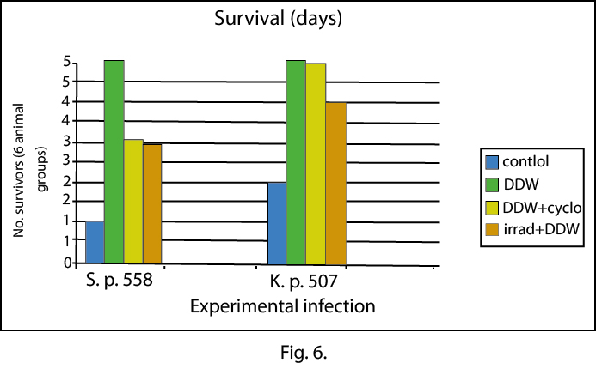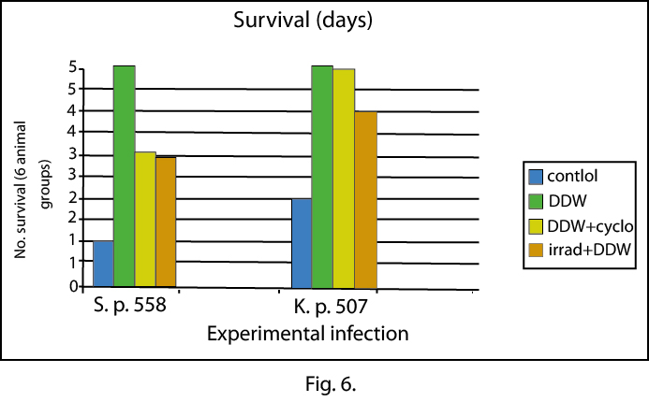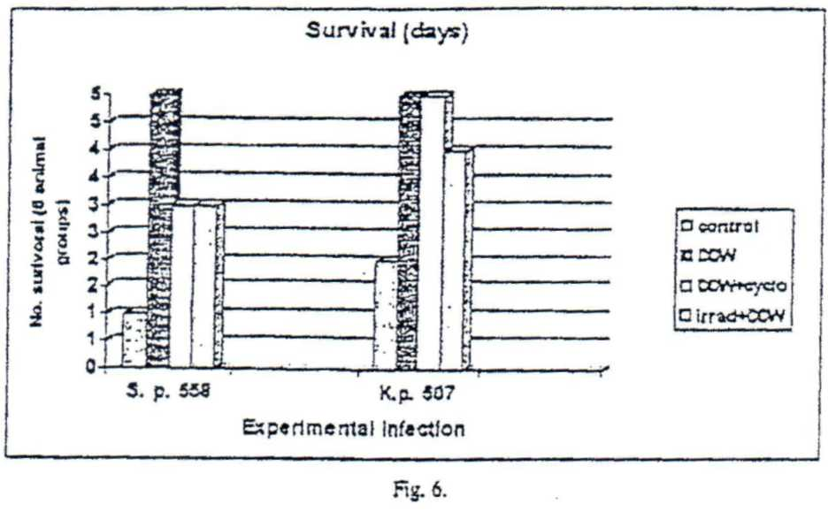

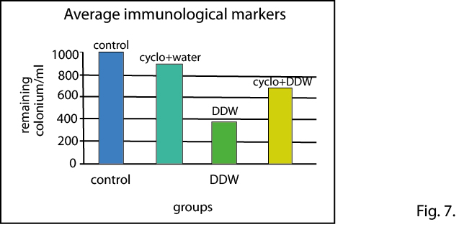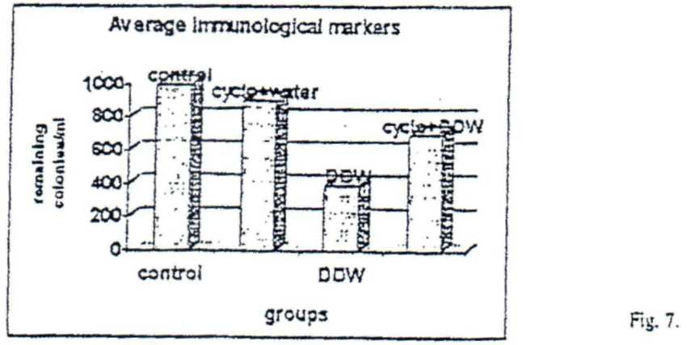

The indirect parameters of the non-specific immunity (opsonic and bactericidal capacity of the serum, phagocytic capacity of the peritonea! macrophages) have been definitely superior compared to those in the control groups, but less efficient in mice treated with cyclophosphamide (Fig. 7).

**CONCLUSIONS**

Organic deuterium depletion by replacing the drinking water of the test animals has powerful stimulating effects on the non-specific immunity. The objective parameters (WBC count, leukocyte formula), and the indirect parameters (opsonic and bactericidal capacity of the serum and the phagocytic capacity of the peritoneal macrophages) of the non-specific immune activity studied in animals subjected to immunosuppressor treatments through various mechanisms (irradiation, administration of karyolysinc or cyclophosphamide) have demonstrated the preservation or even the increase of the non-specific immunity. Unlike them, the controls either have not survived the treatments or showed a marked immune deficiency.

**IV. EFFECTS OF DEUTERIUM-DEPLETED WATER ON CULTURES**

**OF HELA CELLS**

The effects of deuterium depletion in cultures were investigated using deuterium-depleted **water** in various concentrations (30 ppm, 90 ppm and normal water with 145-150 ppm deuterium).

**MATERIALS AND METHOD**

The biological material used in this protocol is represented by malignant HeLa cells of human origin obtained from a cervical carcinoma. Neoplasic HeLa cells were grown and maintained in a monolayer in glass cells with growth and support media **MEM (Modified** Eagle Media), supplemented with fetal calf serum (10%, respectively ***2%).*** thermostated at 36.5-37°C.

The culture tubes were seeded with 1x105 HeLa cells, dislodged from the glass substrate with trypsin and EDTA and re-suspended, by pipetting, in the growth **MEM** enriched with nutrient consisting in 10% fetal calf serum.

After 24 hours, when the stage of monolayer was reached by the cultures in the logarithmic development stage (maximal division capacity of the tumoral cells), the growth medium was replaced with media according to the experimental variants HeLa control, and treated. The latter contained in the growth medium instead of the 15 ml distilled water an equivalent volume of deuterium-depleted water dilution.

After 24 hrs, 48 hrs and. respectively. 72 hrs of culture, the medium was emptied from the test tubes and the cell layer was washed with TFS and subjected to biochemical determinations of total protein content (mg/ml protein/culture) through successive phases as in the Lowry method, modified by Oyama.

Five tubes of culture were used for each category of samples and time interval. That represented the minimum number necessary for statistical calculations by means of Student's "P" test.

The i***n vitro*** cytotoxic and/or cytostatic action was evaluated by estimating the concentration of total proteins, of protein dynamics and of the growth degree of cultures during the evolution of the control and treated cultures. All these parameters express the level of protein synthesis and the division rate of the HeLa cells specific to each kind of culture.

The assessment of the significance of cytotoxic and/or cytostatic action ***in vitro*** for each variant of deuterium-depleted water included in the pre-screening and added to the various types of incubation media was based both on the comparative analysis of the values of the evaluation indexes, characteristic for each experimental variant, and on the standard value (50% inhibition of the culture development) sec by the American program for preliminary testing, aimed at discoverying new potentially active cancerostatic agents.

**RESULTS**

The average level of the total protein content, the protein dynamics (its direction and amplitude), and the degree of development of the HeLa cultures incubated for 24, respectively 48 hours in the growth media containing various types of deuterium-depleted water are not significantly different from the cytotoxic and/or cytostatic parameters of the control cultures (Fig. 8).

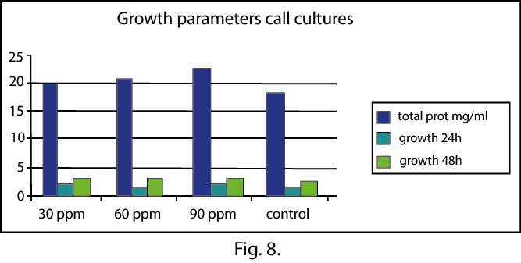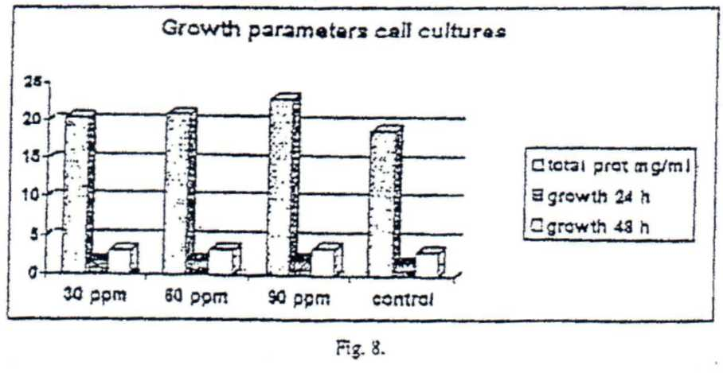

We conclude that deuterium-depleted water, in the dilution used does not efficiently disturb protein synthesis or mitosis of the HeLa neoplasic cells.

Although without cytotoxic and/or cytostatic relevance, it is worth emphasizing the fact that there is an inverse ratio between deuterium percentage in the solution and the intensity of its effect on the HeLa cultures. In other words the lower the concentration of the heavy isotope of hydrogen deuterium, in the culture water, the higher the interferences with several cellular processes.

**GENERAL CONCLUSIONS**

The radioprotective effect of DDW produces the increase of radioresistance by the stimulation of non-specific immune defense mechanisms, represented by:

-a statistically significant increase in the percentage of PMN and lymphocytes in peripheral blood;

- the increase of the opsonic and bactericidal capacities of the serum in the animals chronically treated with DDW versus the control groups;

- the increase of the phagocytic capacity of the peritoneal macrophages in the groups treated with DDW;

- the improvement of the survival coefficient in the groups created with DDW, in conditions of experimental infection with Klebsiella pneumoniae 507 and Streptococcus pneumoniae 558;

- testing in tumoral cells (HeLa) cultures produced no significant changes in protein synthesis or in the mitosis of neoplasic cells;

This is an approach to radioprotection from a new angle that makes available a new instrument for changing the deuterium concentration in biological fluids.

Several study hypotheses concerning the cellular and molecular basis of the radioprotective effects are available, but further investigations are needed.

**REFERENCES**

**ADAMS W.H.. ADAMS D.G. (1988), Effects of deuteration on hematopoicsis in the mouse.**

***J. Pharmacol Exp. Ther., 2*44(2). 633-9.**

**AHLERS I., FORET M., LEMM U. (1983). Does 2Н2О also protect membrane-bound enzymes?,**

**Enzim,30(I). 70-3.**

**ALTER MATT H.*J., G*EBBERS J.0., LAISSUE J.A. (1988). Heavy water delays growth of human**

**carcinoma in nude mice. *Cancer.* 62(3). 4*62-6.***

**BACQ *Z.*M.(1965). *Chemical Protection Against Ionizing Radiation,* Charles C. Thomas,**

**publishers, Springfield Illinois.**

**DORING 0., BOTTGER M. (1992). Effect of D20 on maize plasmalemma ATPase and electron**

**transport coupled proton pumping. B*iochem. Biophys. Res. Commun..* 182(2), 870-876.**

**DORING 0., BOTTGER M. (1992), Effect of D2O on maize plasmalemma ATPase and electron**

**transport coupled proton pumping, *Biachem. Biophys. Res. Commun..* 182(2). 870-6.**

**GOODMAN GILLMAN A.. GOODMAN L. S.. GILMAN A. (1990). *The Pharmacological Basis of***

***Therapeutics. 6th* edition, McMillan Publishing Co.. Inc. New York. Toronto, London.**

**HAKURA A.. KOHADA K.. KAWAZOE Y. - Inhibitory effect of heavy water on mutability of**

**chemically injured Escherichia coli cdli.**

**JOENJE H.. OOSTRA А. В.. WANAMARTA A. H. (1983). Cytogenetic toxicity of D20 in human**

**lymphocyte cultures. Increased sensitivity in Fanconi's anemia. *Experientia.* 39(7). 782-4.**

**KARAN D. M.. MACEY R. I.. (1980). The permeability of the human red cell to deuterium oxide**

**(heavy water). *J. Cell. Physiol.,* 104(2). 209-14.**

**LACASSAGNE A.. DUPONT A.. VAN CANEGHEM P., CIVATTE J. (1980). Lis*ions provoqueez***

***par les radiations ionisanics.* Masson et Cie.. Librairies de l'Acadcmie, Paris.**

**LAISSUE J. A. BURKI H.. BERCHTOLD W. (1982). Survival of tumor-bearing mice exposed to**

**heavy Water or heavy water plus methotrexate. *Cancer Res..* 42(3). 1125-9.**

**LAMPRECHT J.. SCHROETER D.. PAWELETZ N. (1990). Mitosis arrested by deuterium oxide.**

**Light microscopic, immunofluorescence and ultrastructural characterization, *Eur. J. Cell***

***Biol* 51(2), 303-12.**

**LOBYSHEV V. I.. FOGEL L. IAKOVENKO L V.. REZAEVA M. N.. TVERDISLOV V. A.**

**(1982). D2O as a modifier of ionic specificity of Na. K-ATPase, *Biofizika.* 27(4). 595-603.**

**RICHTER С. P. (1976). A study of taste and smell of heavy water (99.8%) in rats. - *Proc. Soc. Exp.***

***Biol Med.,* 152(4). 677-84.**

**SCHROETER D„ LAMPRECHT J- ECKHARDT R.. FUTTERMAN G., PAWELETZ N. (1992).**

**Deuterium oxide (heavy water) arrests the cell cycle of PtK2 cells during interphase. E*ur. J.***

***Cell Biol.* 58(25. 363-70.**

**SOMLYAI G.. JANCSO G-. JAKLI G.. VASS K., BARNA В.. LAKICS V.. GAAL Т.. Naturally**

**occuring deuterium is essential for the normal growth rate of cells. *FEBS Letters,* vol. 317.**

**(1.2). 1-4.**

**TAKAHASHI Т. C. SATO H. (1983). Effects of heavy water (D2O) on the length of the mitotic**

**period in developing sea urchin cggs. *Cell Struct. Fuct..* 8(4). 357-65.**

**VERENINOV A A. IVAKHNIUK I.S., TOROPOVA F. V. (1985). Heavy water inhibition of the**

**transport of alkaline cations across the muscle membrane. I. A comparison of different types of**

**sodium transfer. *Tsitologiia,* 27(11). 1264-70.**

**WAMBERSIE A.. DUTREIX J, STEENON-SMOES M. R.. OCTAVE-PRIGNOT M. (1978).**

**Influence du debit de dose sur la tolerance intestinale chez la souris. *J. Radiol. Electrol..* 59.**

**(5). 315-322.**

***Received April 20. 1999***